

| Course Number | COE328 |
| --- | --- |
| Course Title | Digital Systems - F2022 |
| Semester/Year | Fall 2022 |
| Instructor | Shazzat Hossain |
| TA Name | Sajjad |

| Lab/Tutorial Report No. | Lab 6 |
| --- | --- |

| Report Title | **Simple General-Purpose Processor** |
| --- | --- |

| Section No. | 11 |
| --- | --- |
| Group No. | N/A |
| Submission Date | Dec 3, 2022 |
| Due Date | Dec3, 2022 |

| Student Name | Student ID | Signature* |
| --- | --- | --- |
| [Hamza Malik](mailto:hamza.ejaz.malik@ryerson.ca) | 501112545 |  |

*\*By signing above you attest that you have contributed to this submission and confirm that all work you have contributed to this submission is your own work. Any suspicion of copying or plagiarism in this work will result in an investigation of Academic Misconduct and may result in a “0” on the work, an “F” in the course, or possibly more severe penalties, as well as a Disciplinary Notice on your academic record under the Student Code of Academic Conduct, which can be found online at:*

[*http://www.ryerson.ca/content/dam/senate/policies/pol60.pdf*](http://www.ryerson.ca/content/dam/senate/policies/pol60.pdf)

**Components:**

Latch 1 & 2

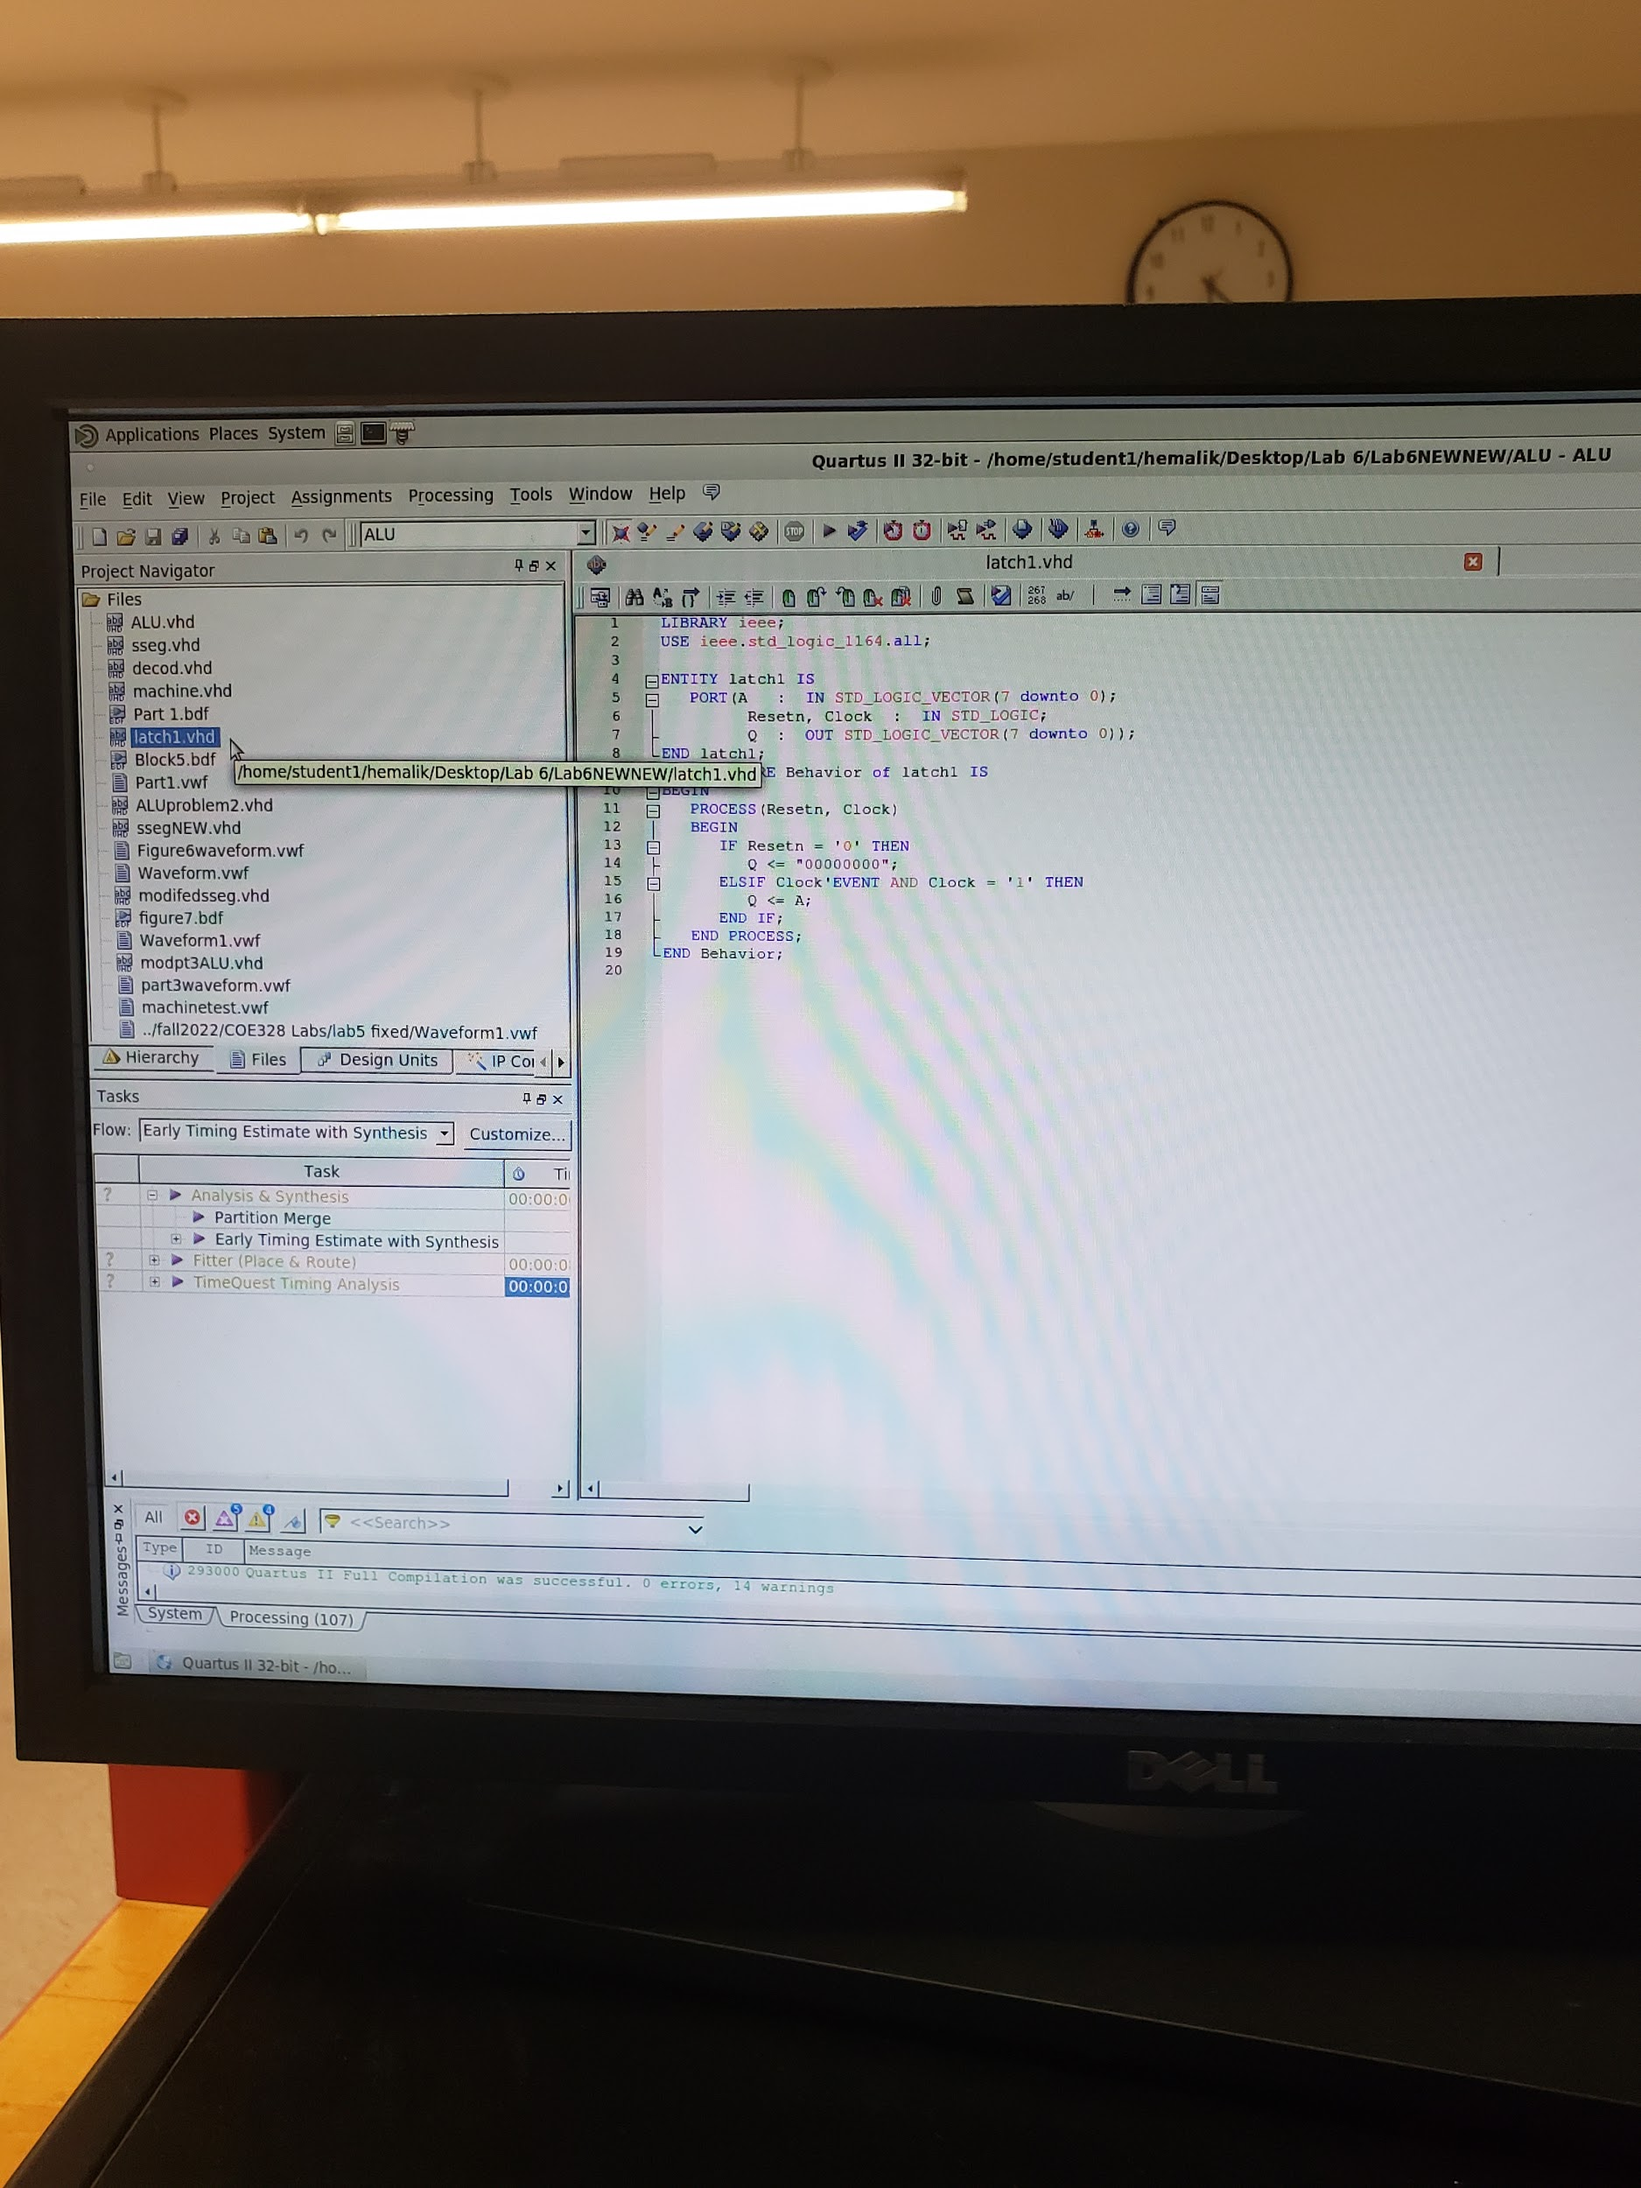 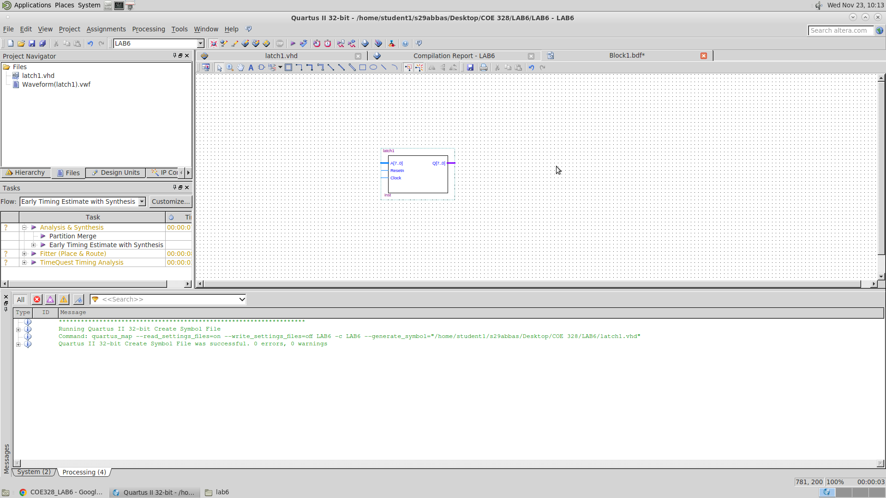

This is Latch 1 VHDL code, and block diagram

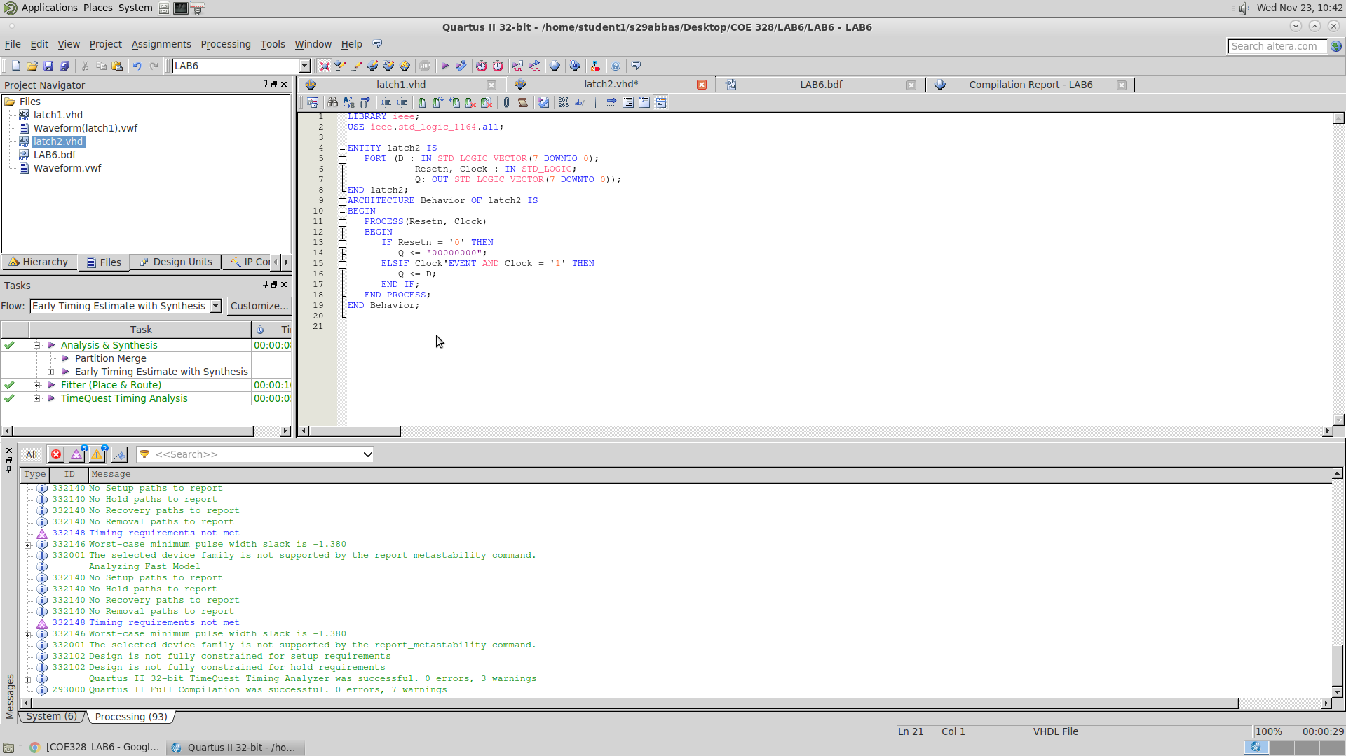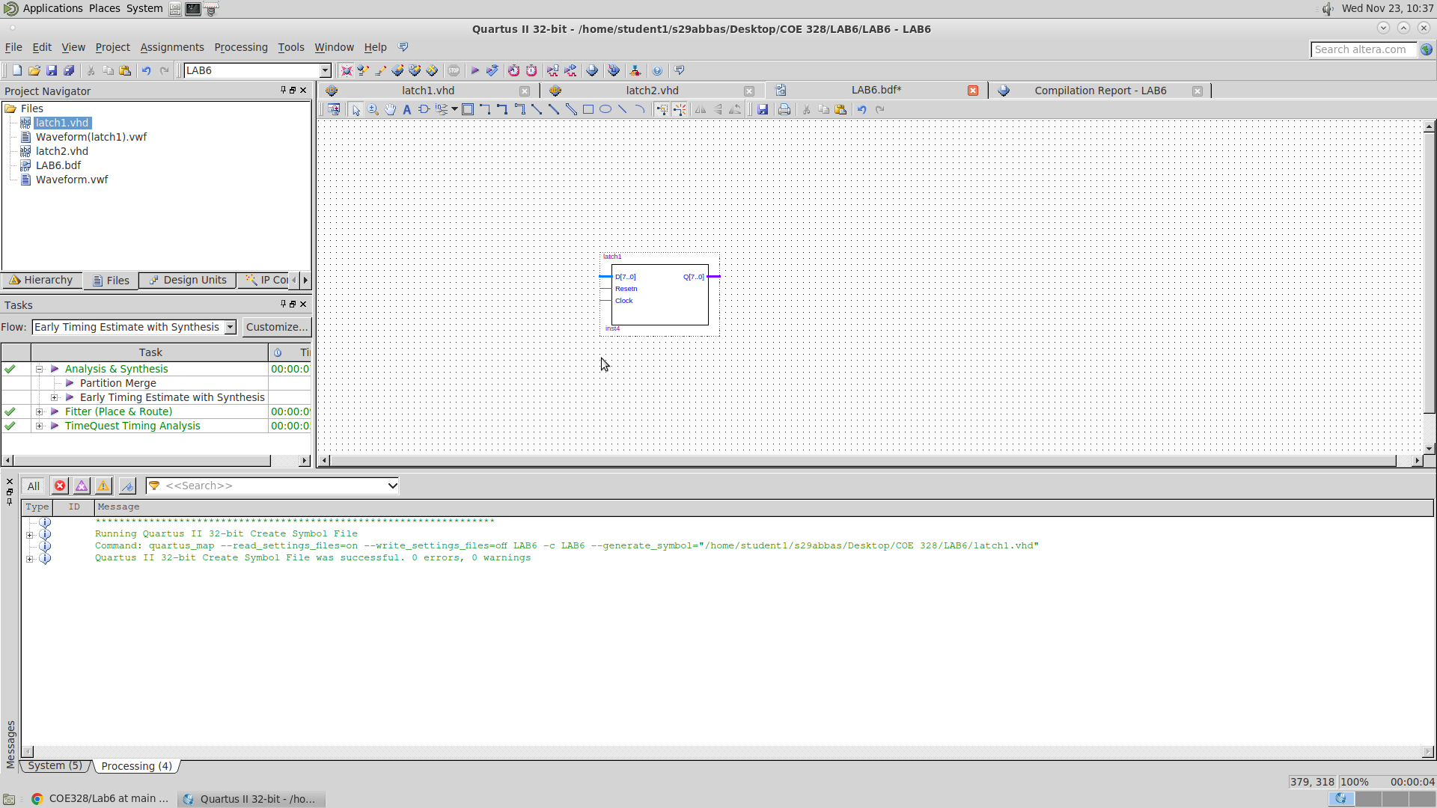

This is Latch 2 VHDL code, and block diagram

4:16 DECODER & FSM

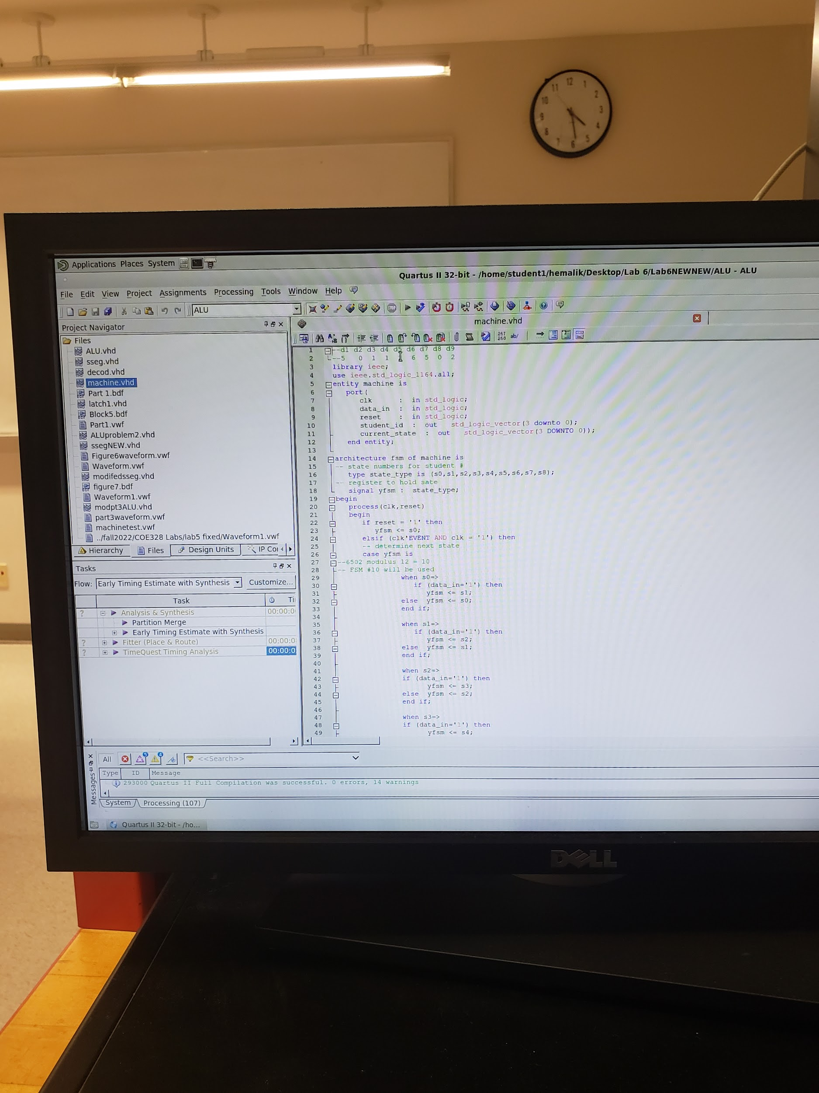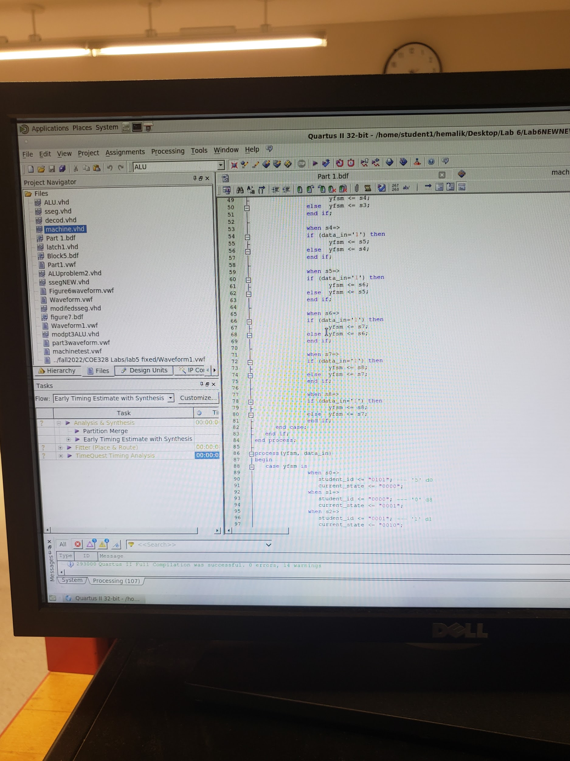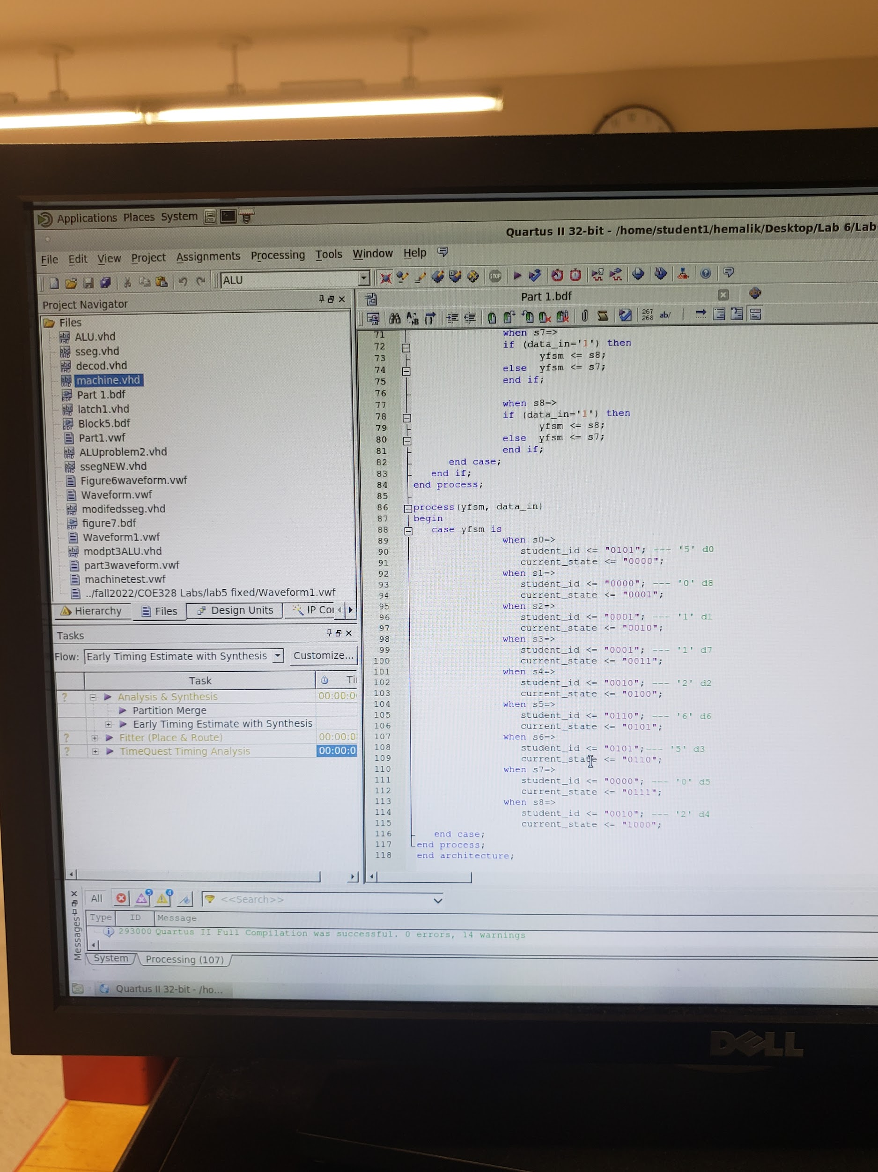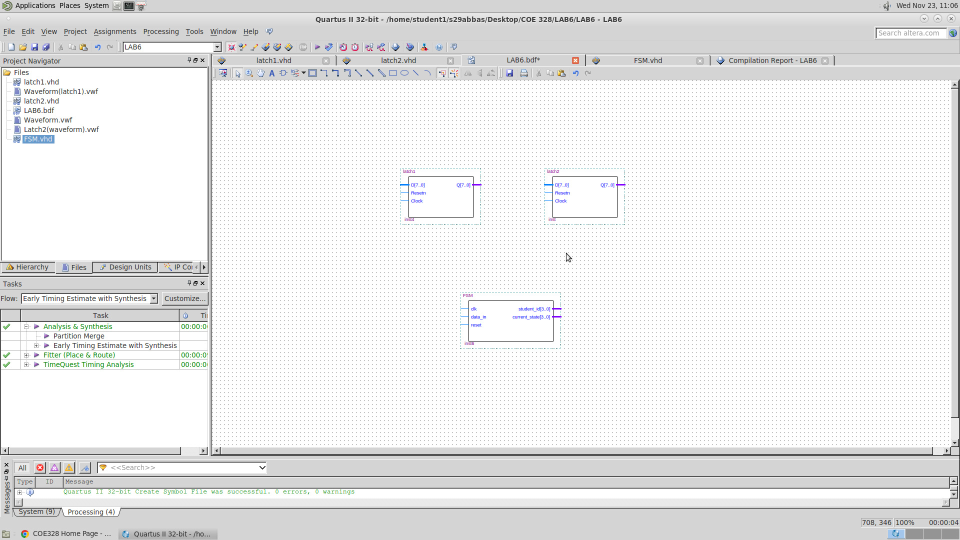

This is the FSM VHDL code, and block diagram

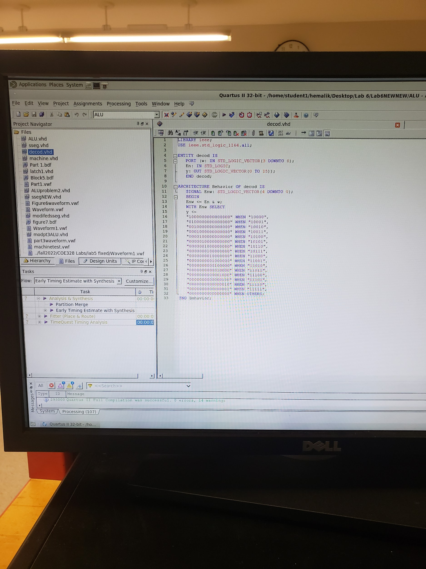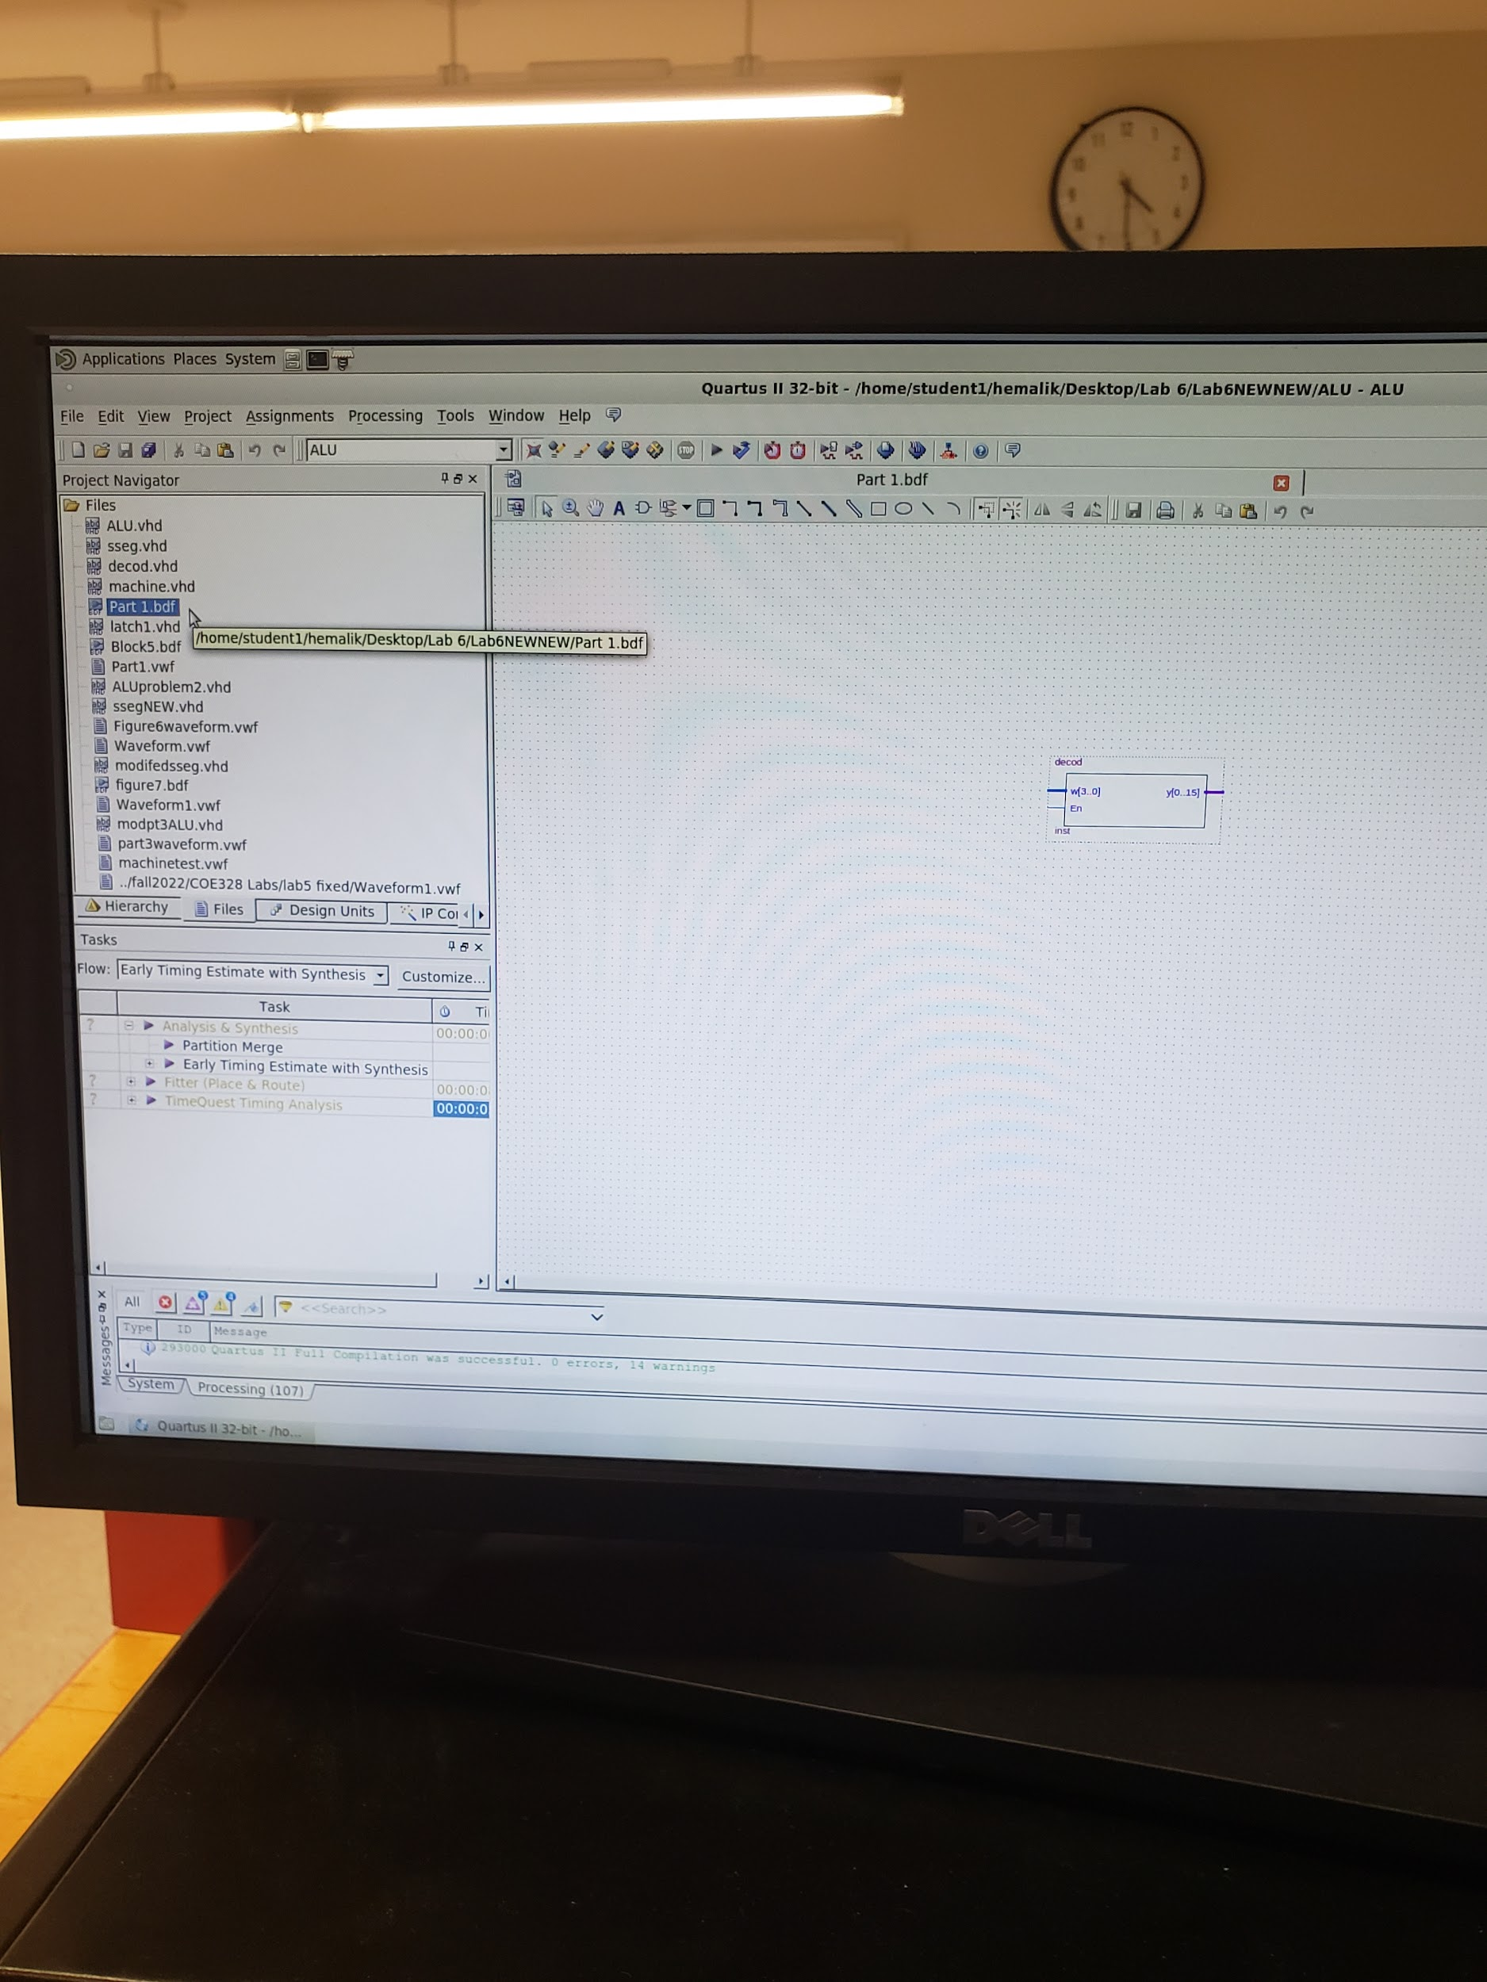

This is the decoder VHDL code, and block diagram

ALU

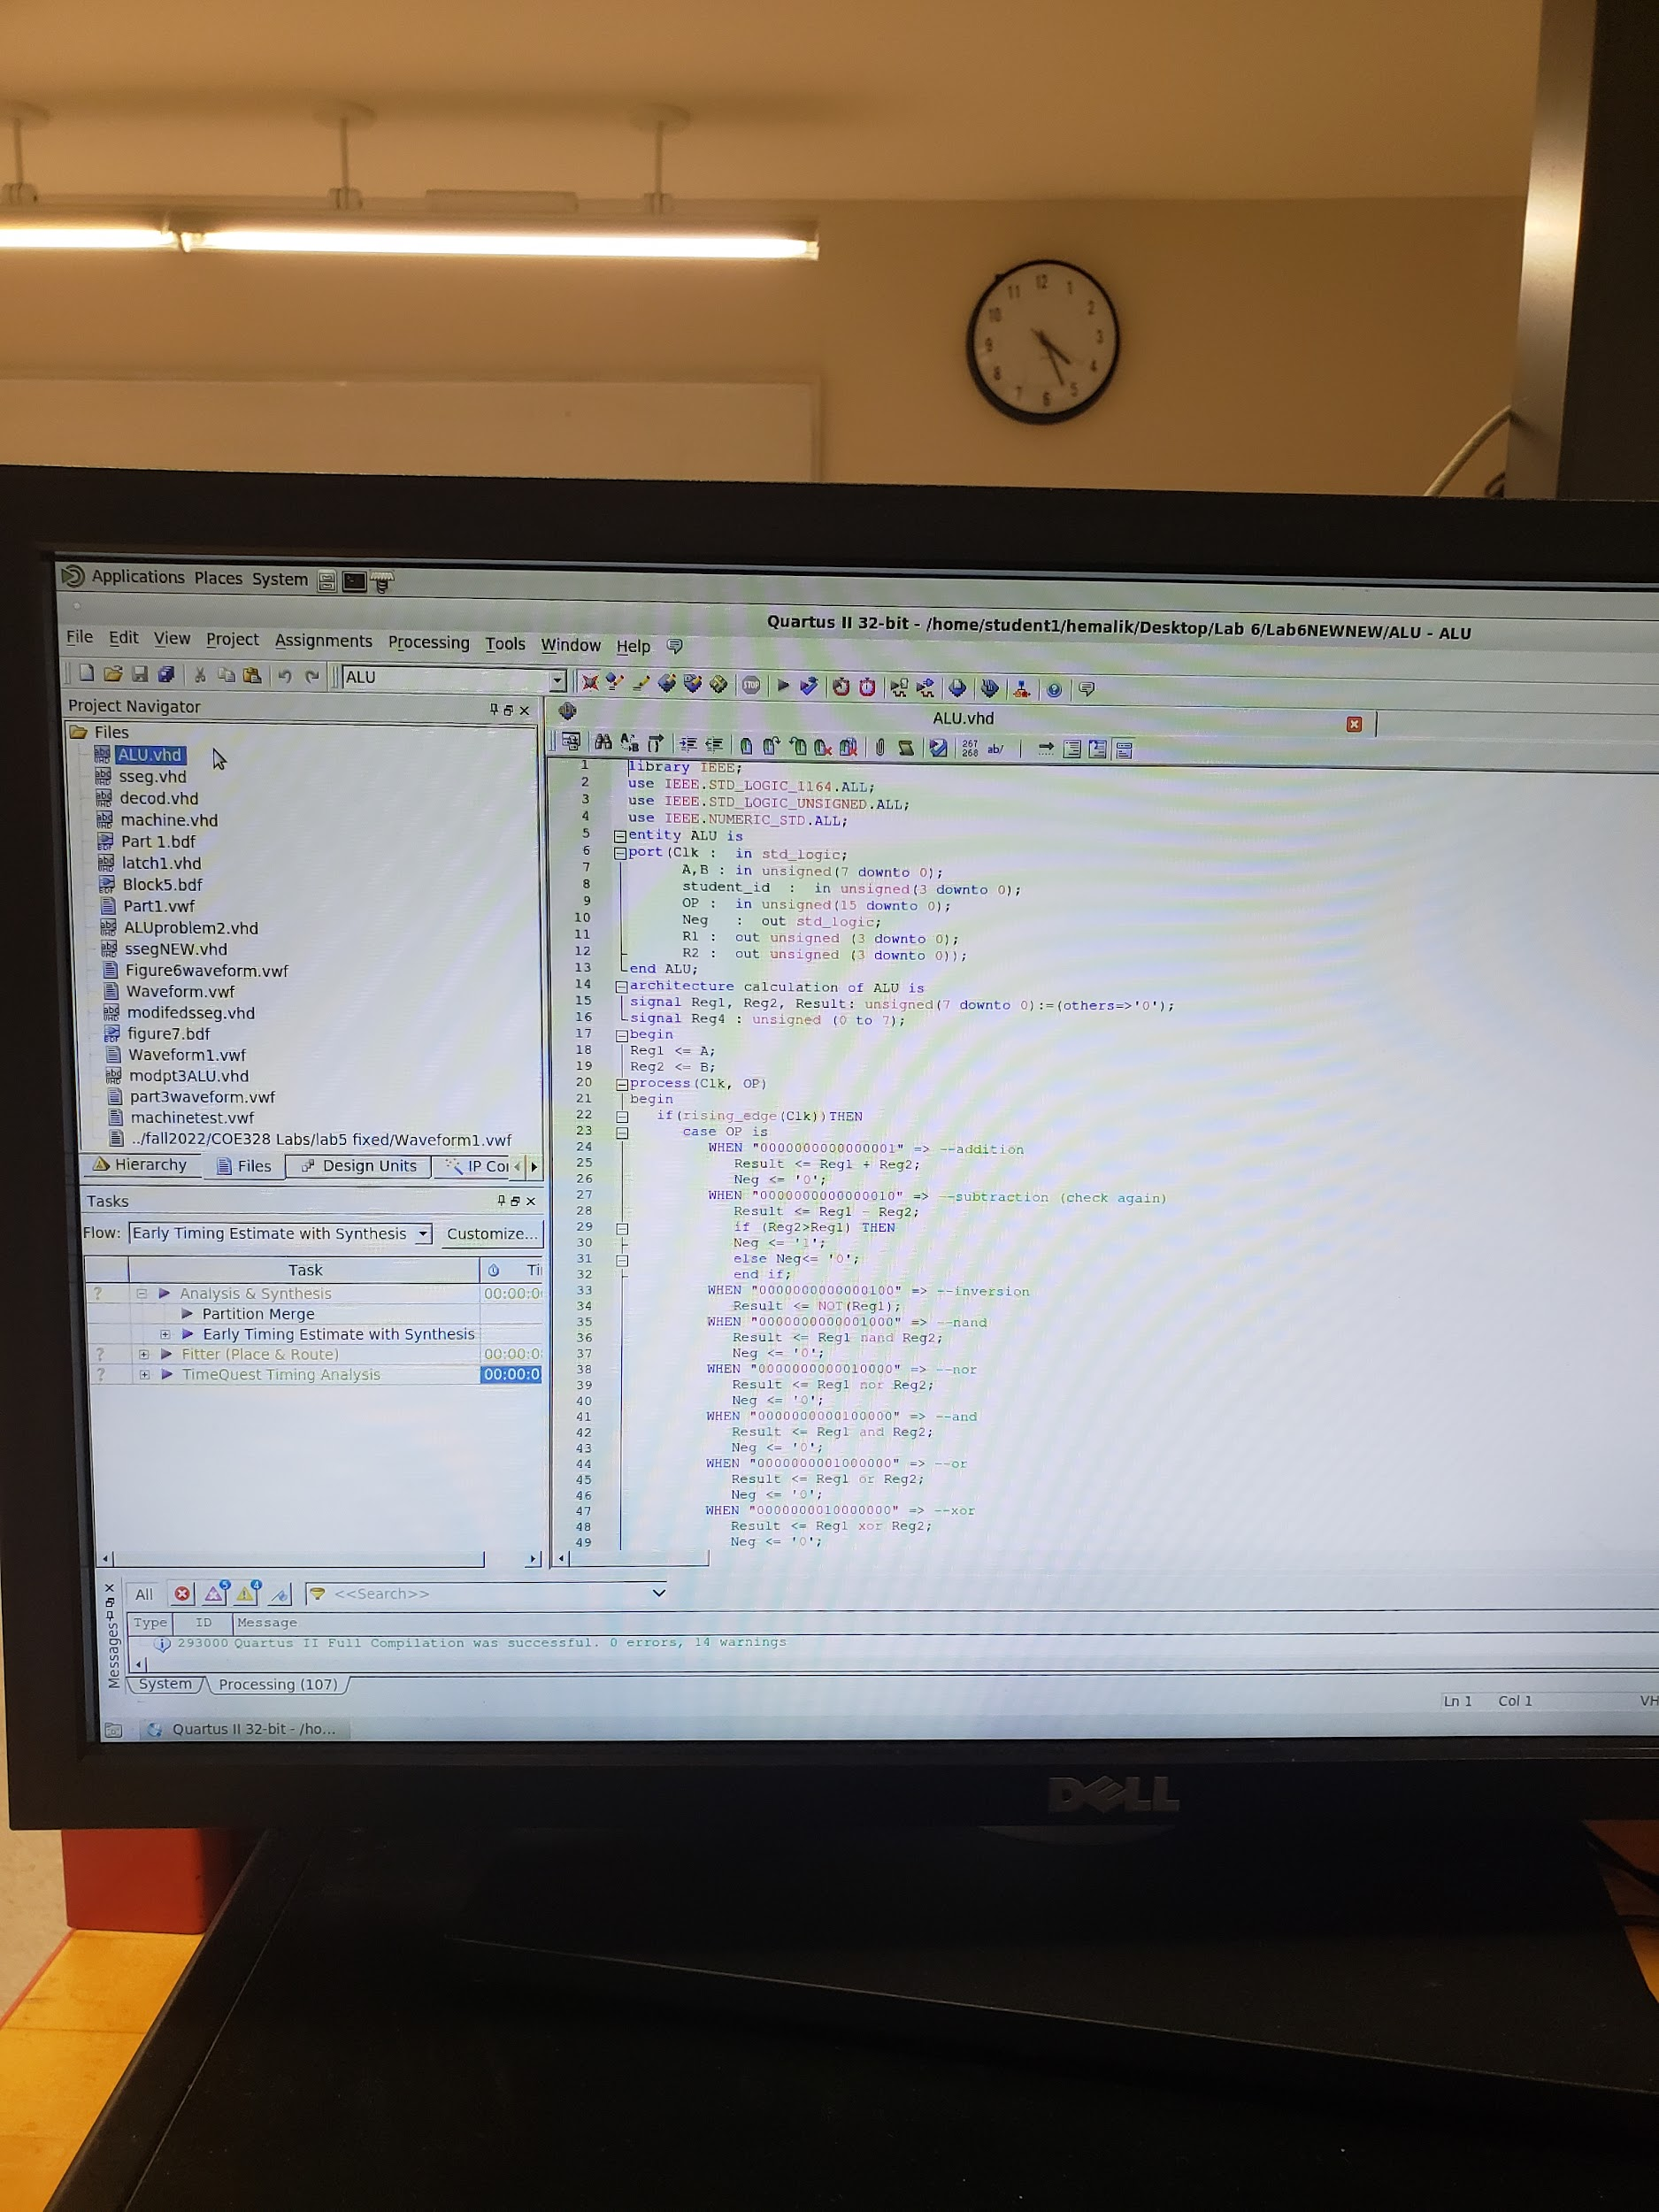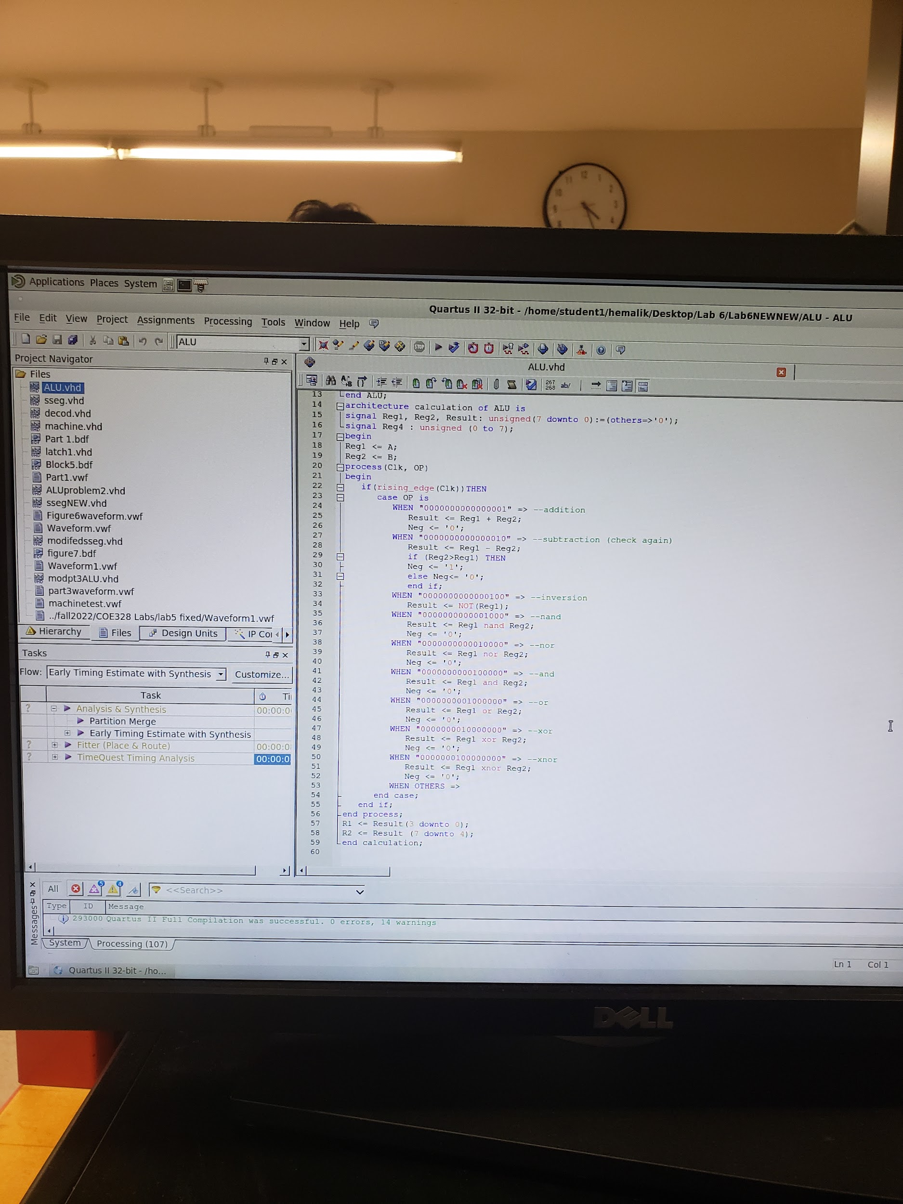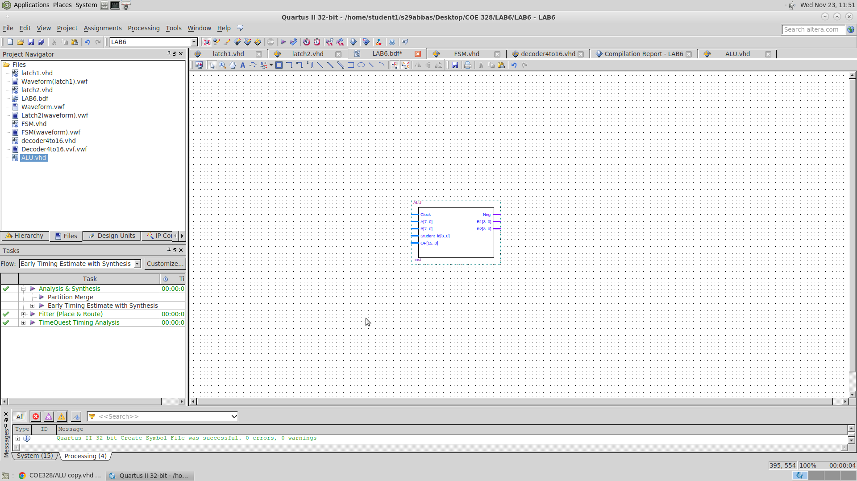

The ALU VHDL code, and block diagram

SSEG & SSEGNEW

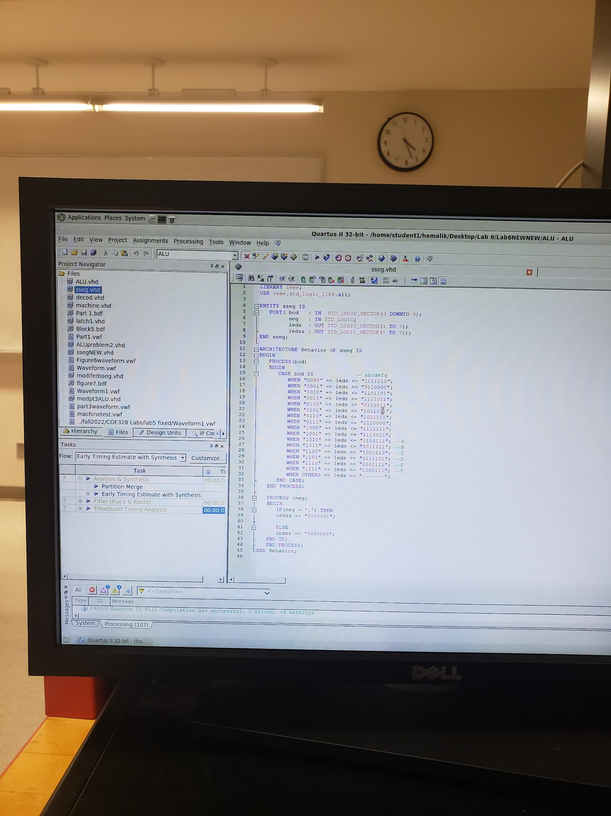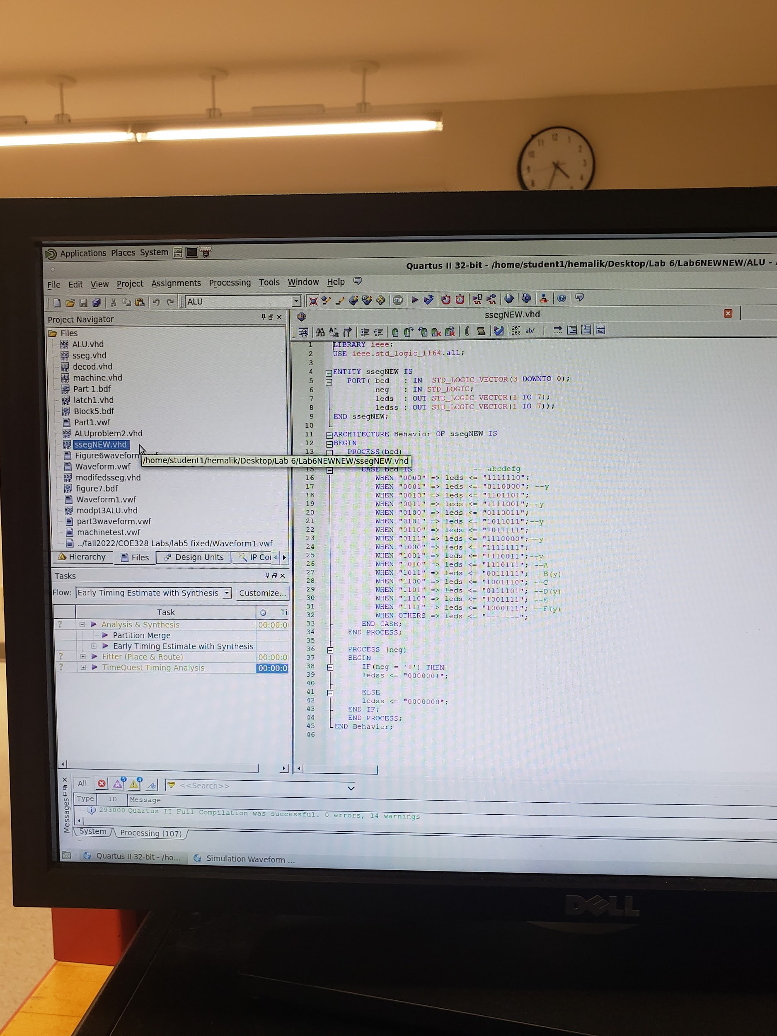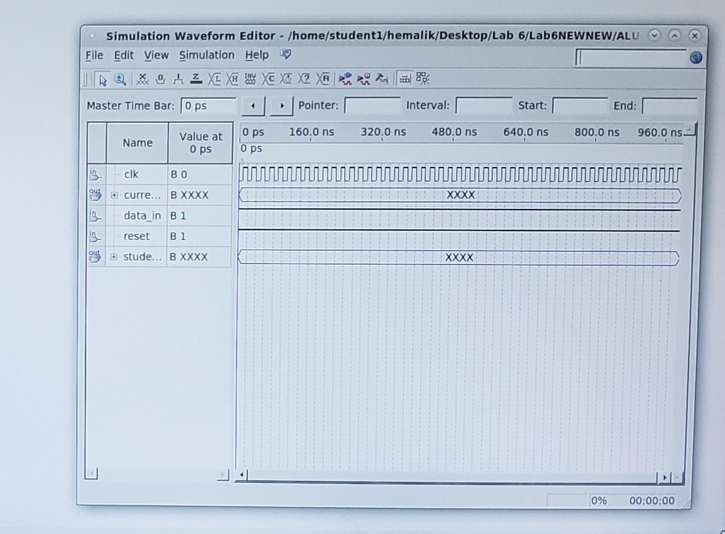

The ALU VHDL code, and waveform. The wave form outputs could not be provided due to software issues in the lab computer, sajjad is aware of it but its all correct and works.

**Final Design For problem 1:**

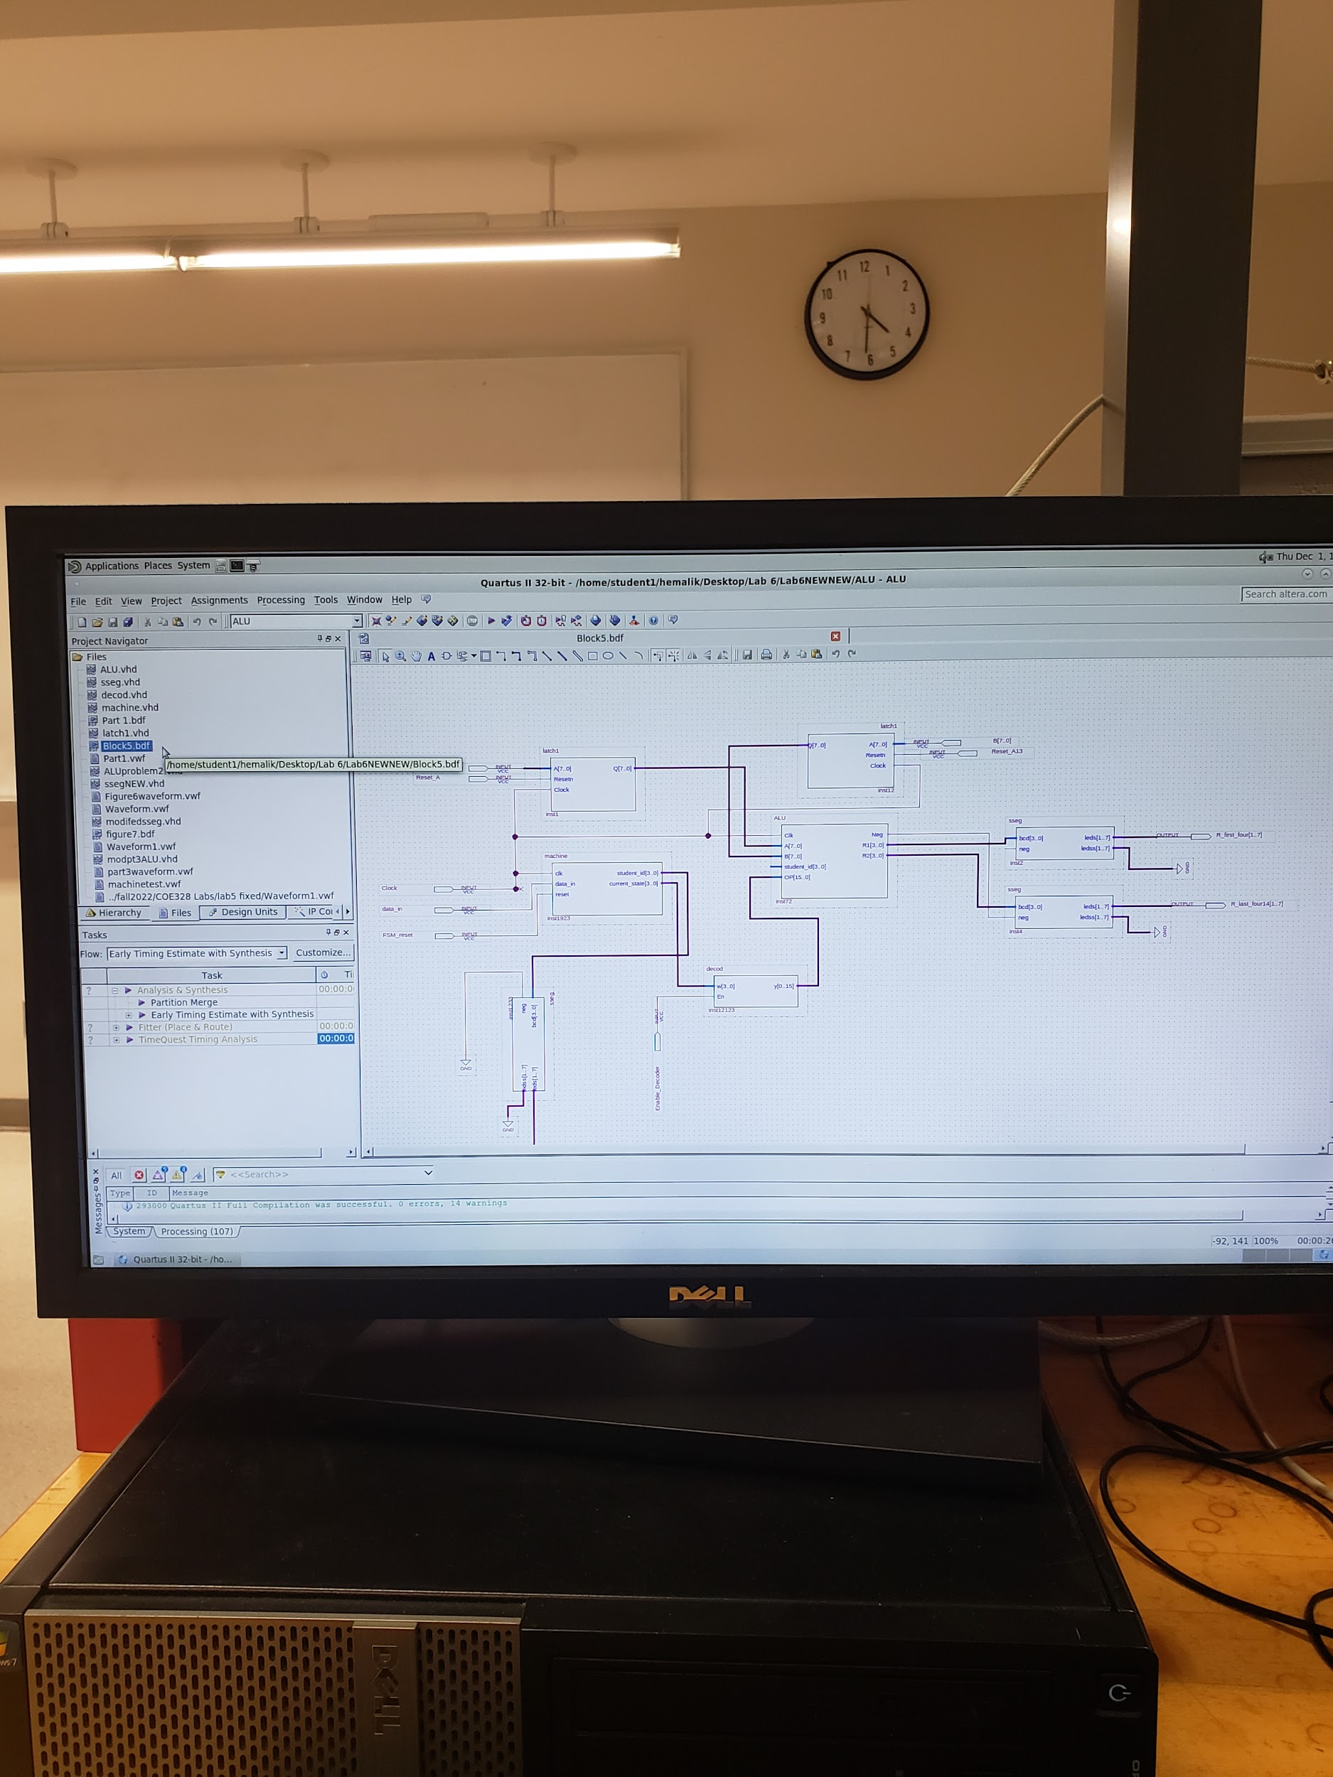

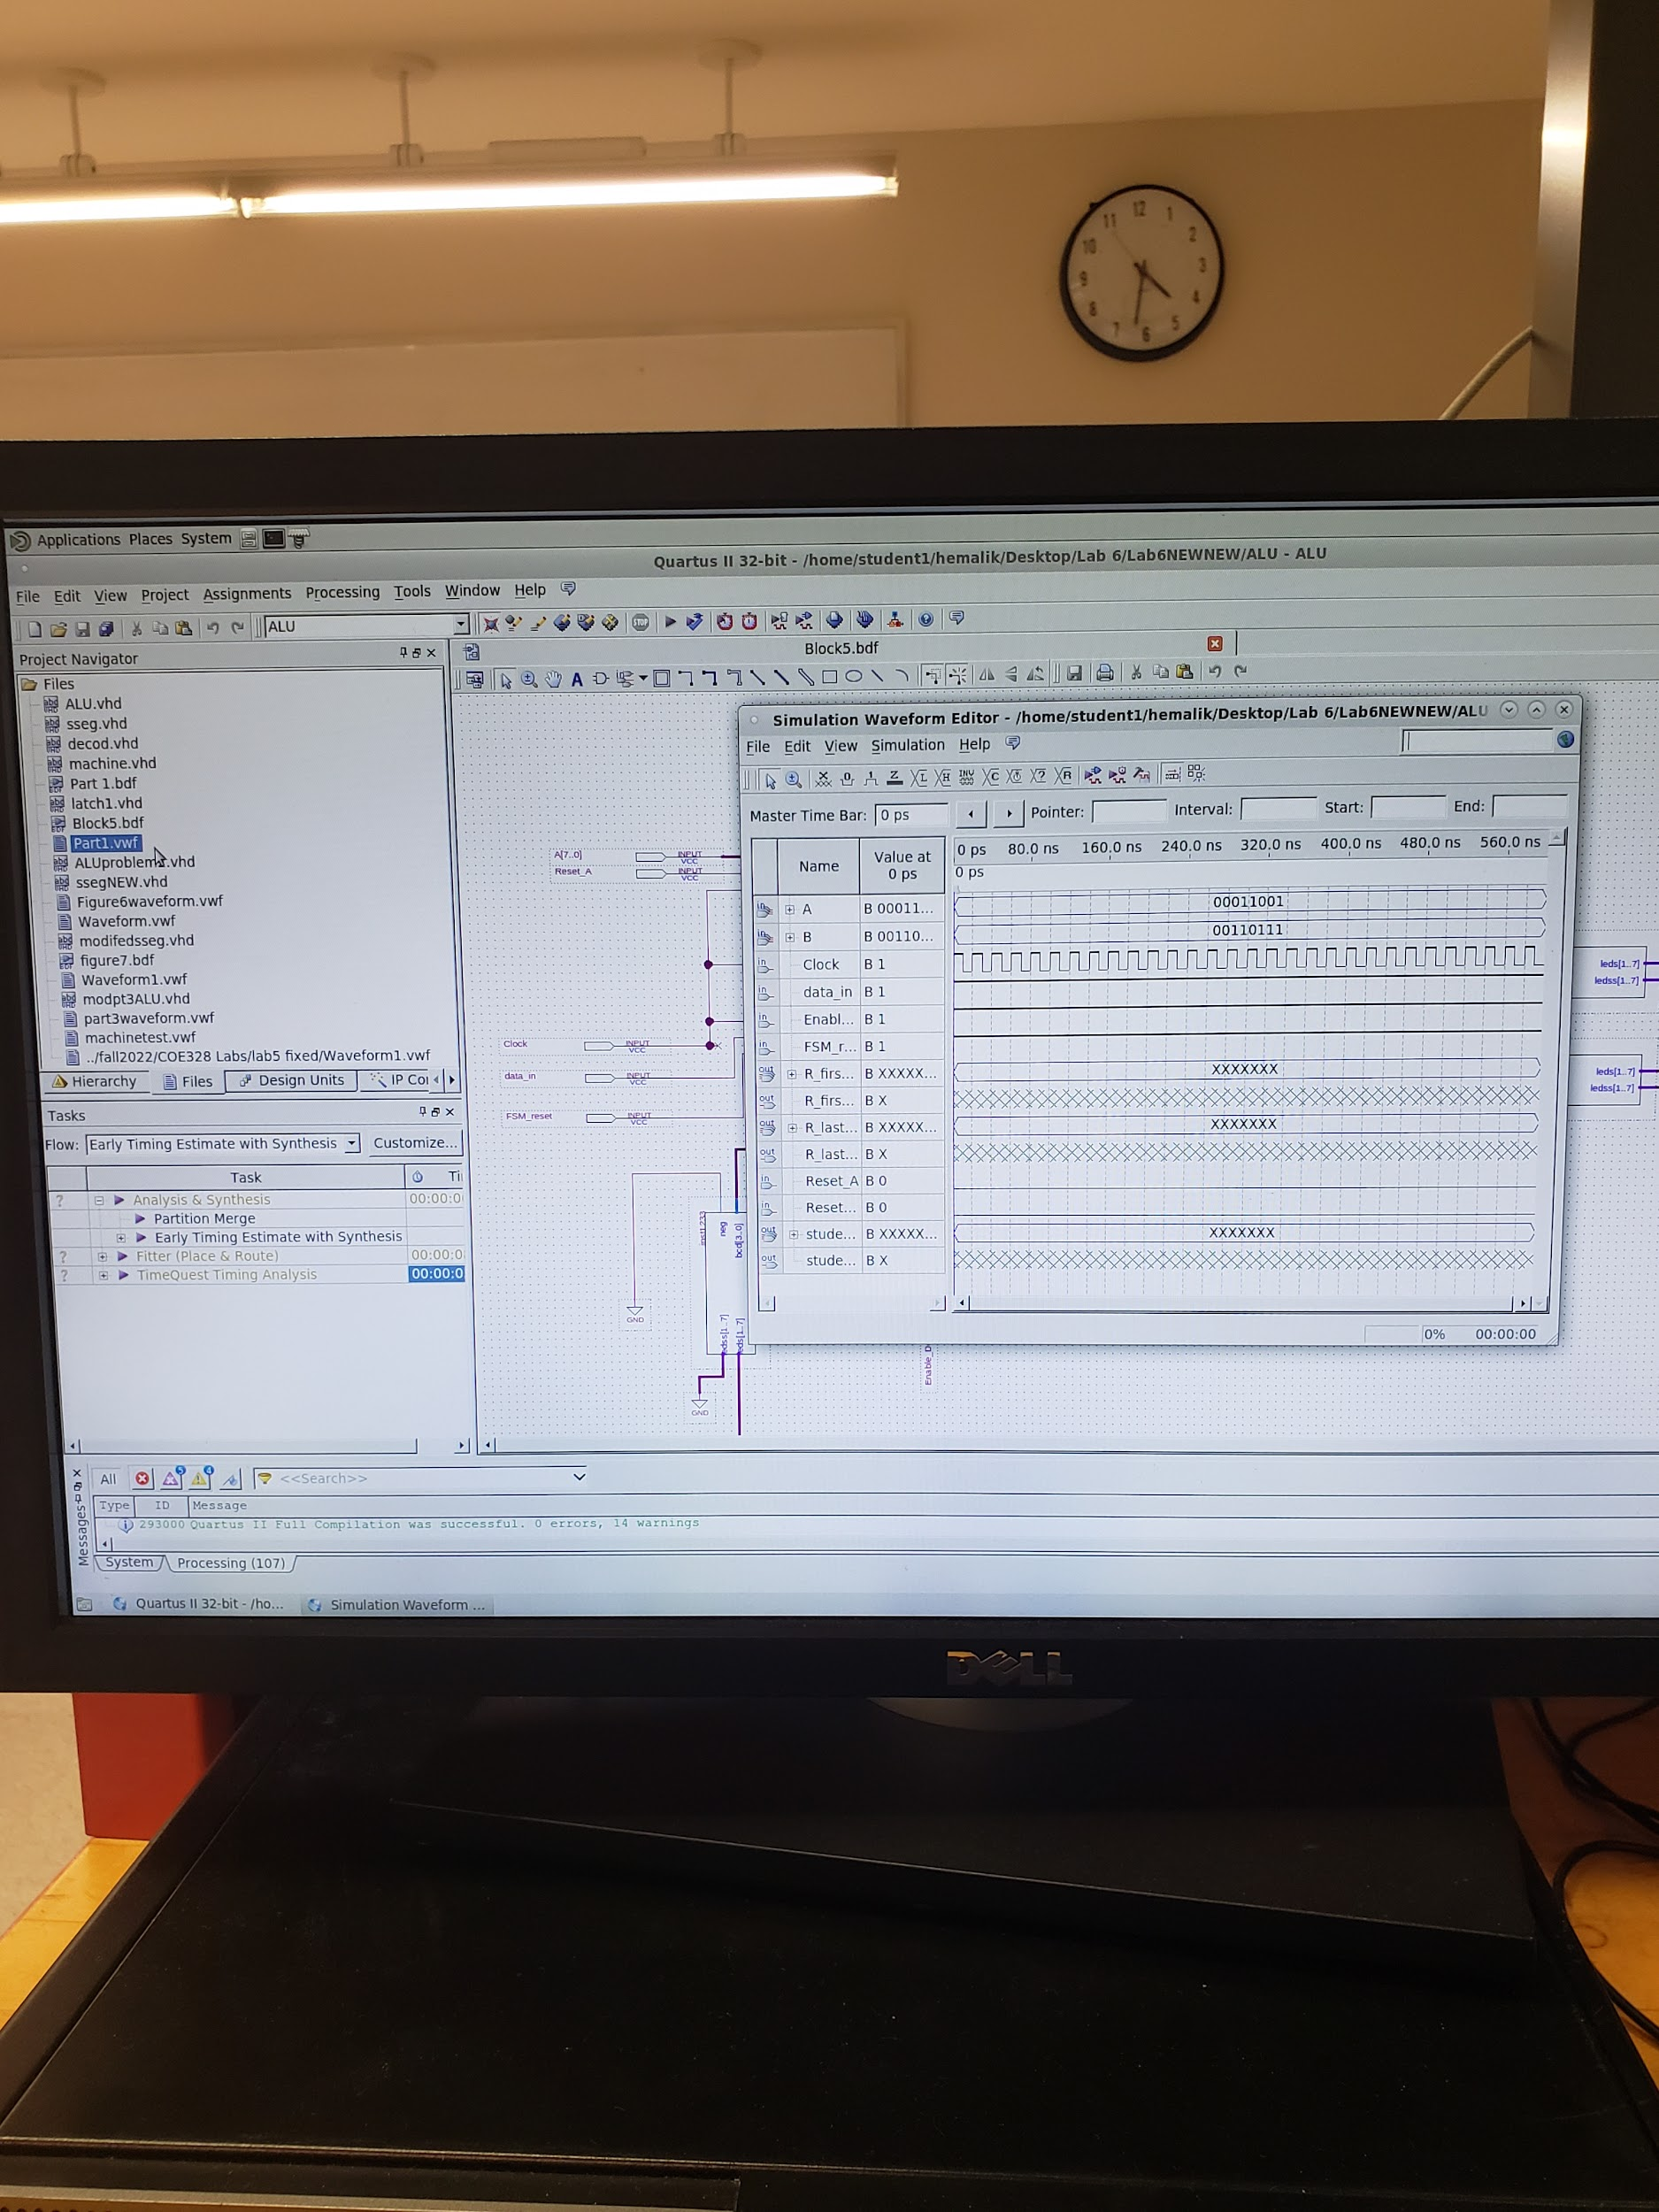

Combined block diagram and waveform for problem 1. Due to software issue in the systemcomputer the waveform couldnot result in a proper output while everything was correct.

**Problem 2:**

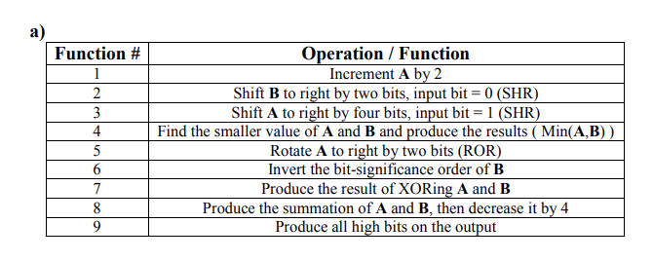

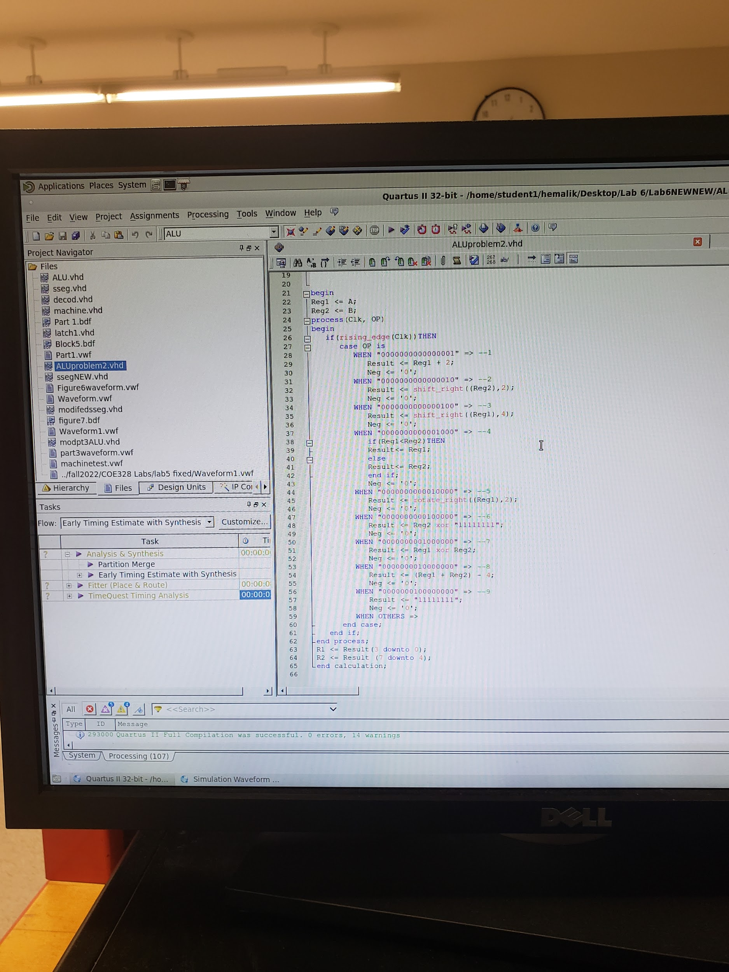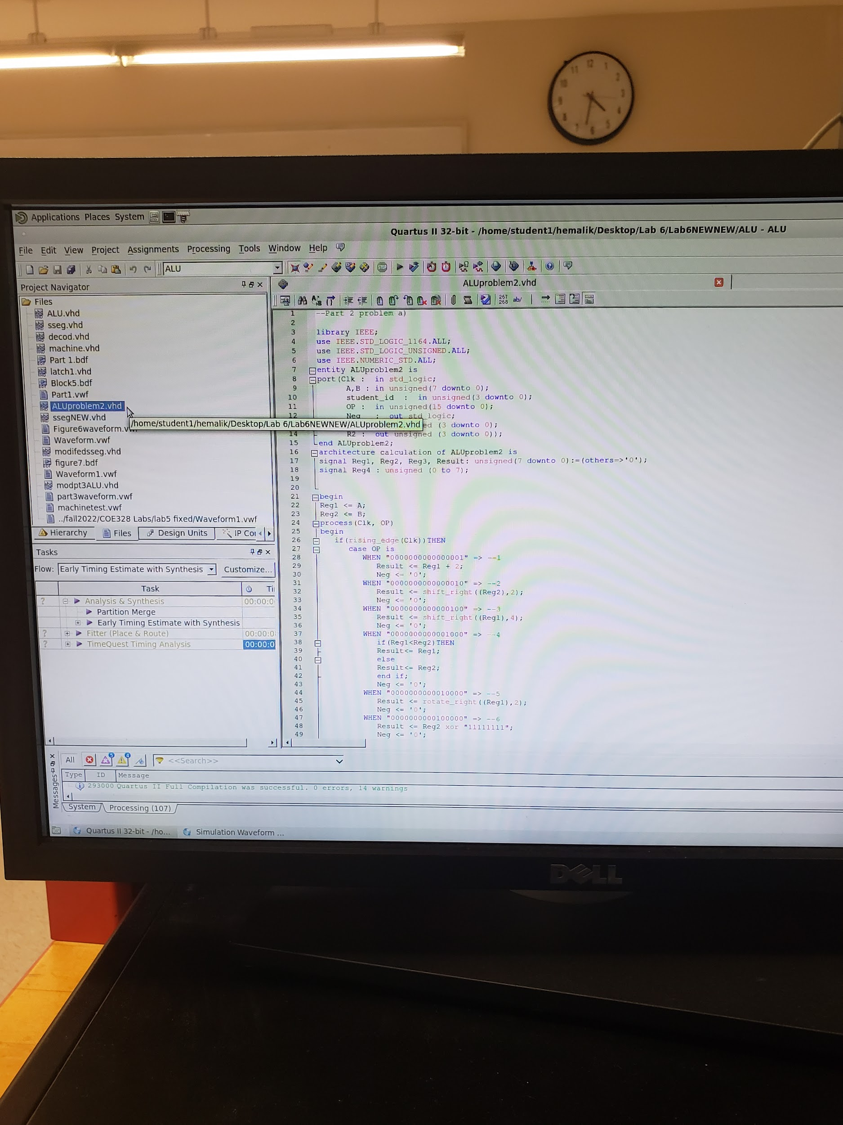

For Problem 2 I chose part a, This is the VHDL code, we were said just to do the vhdl code, the waveform wasnt necessary.

**Problem 3:**

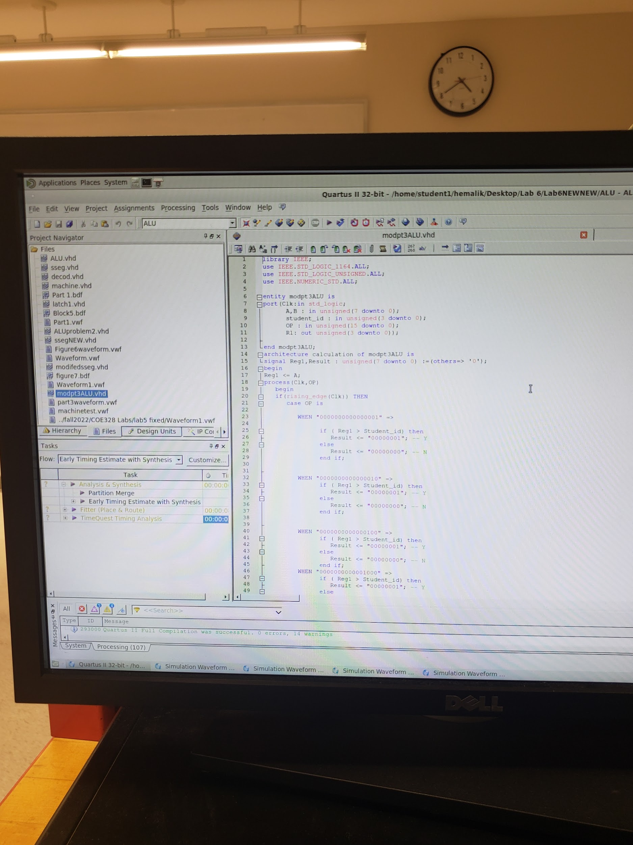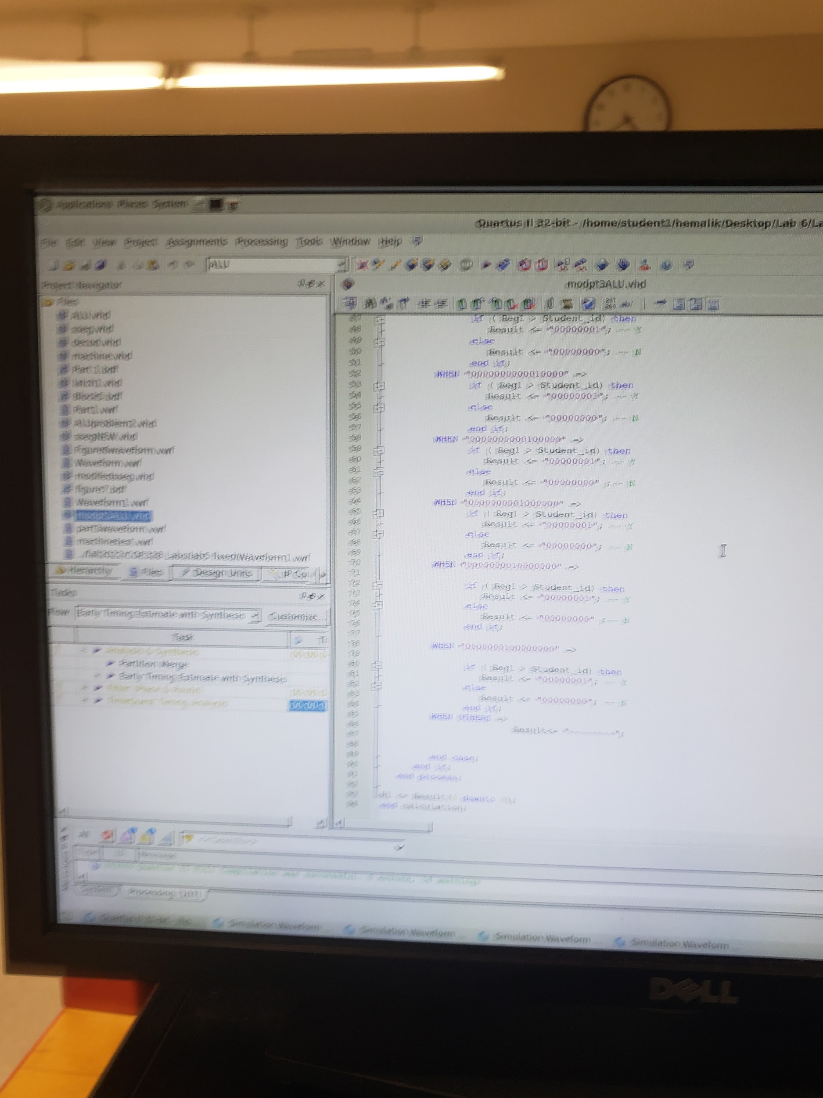

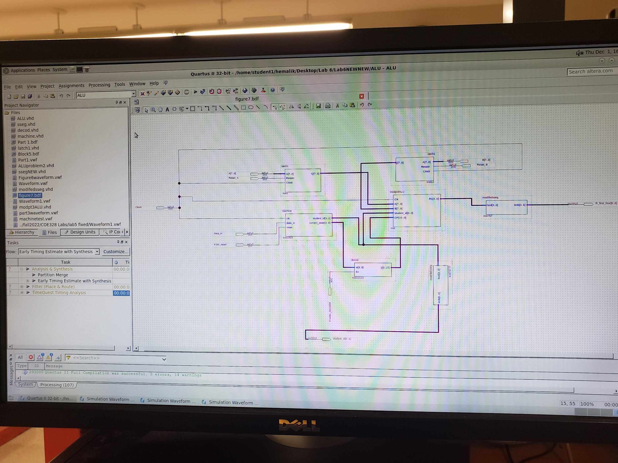

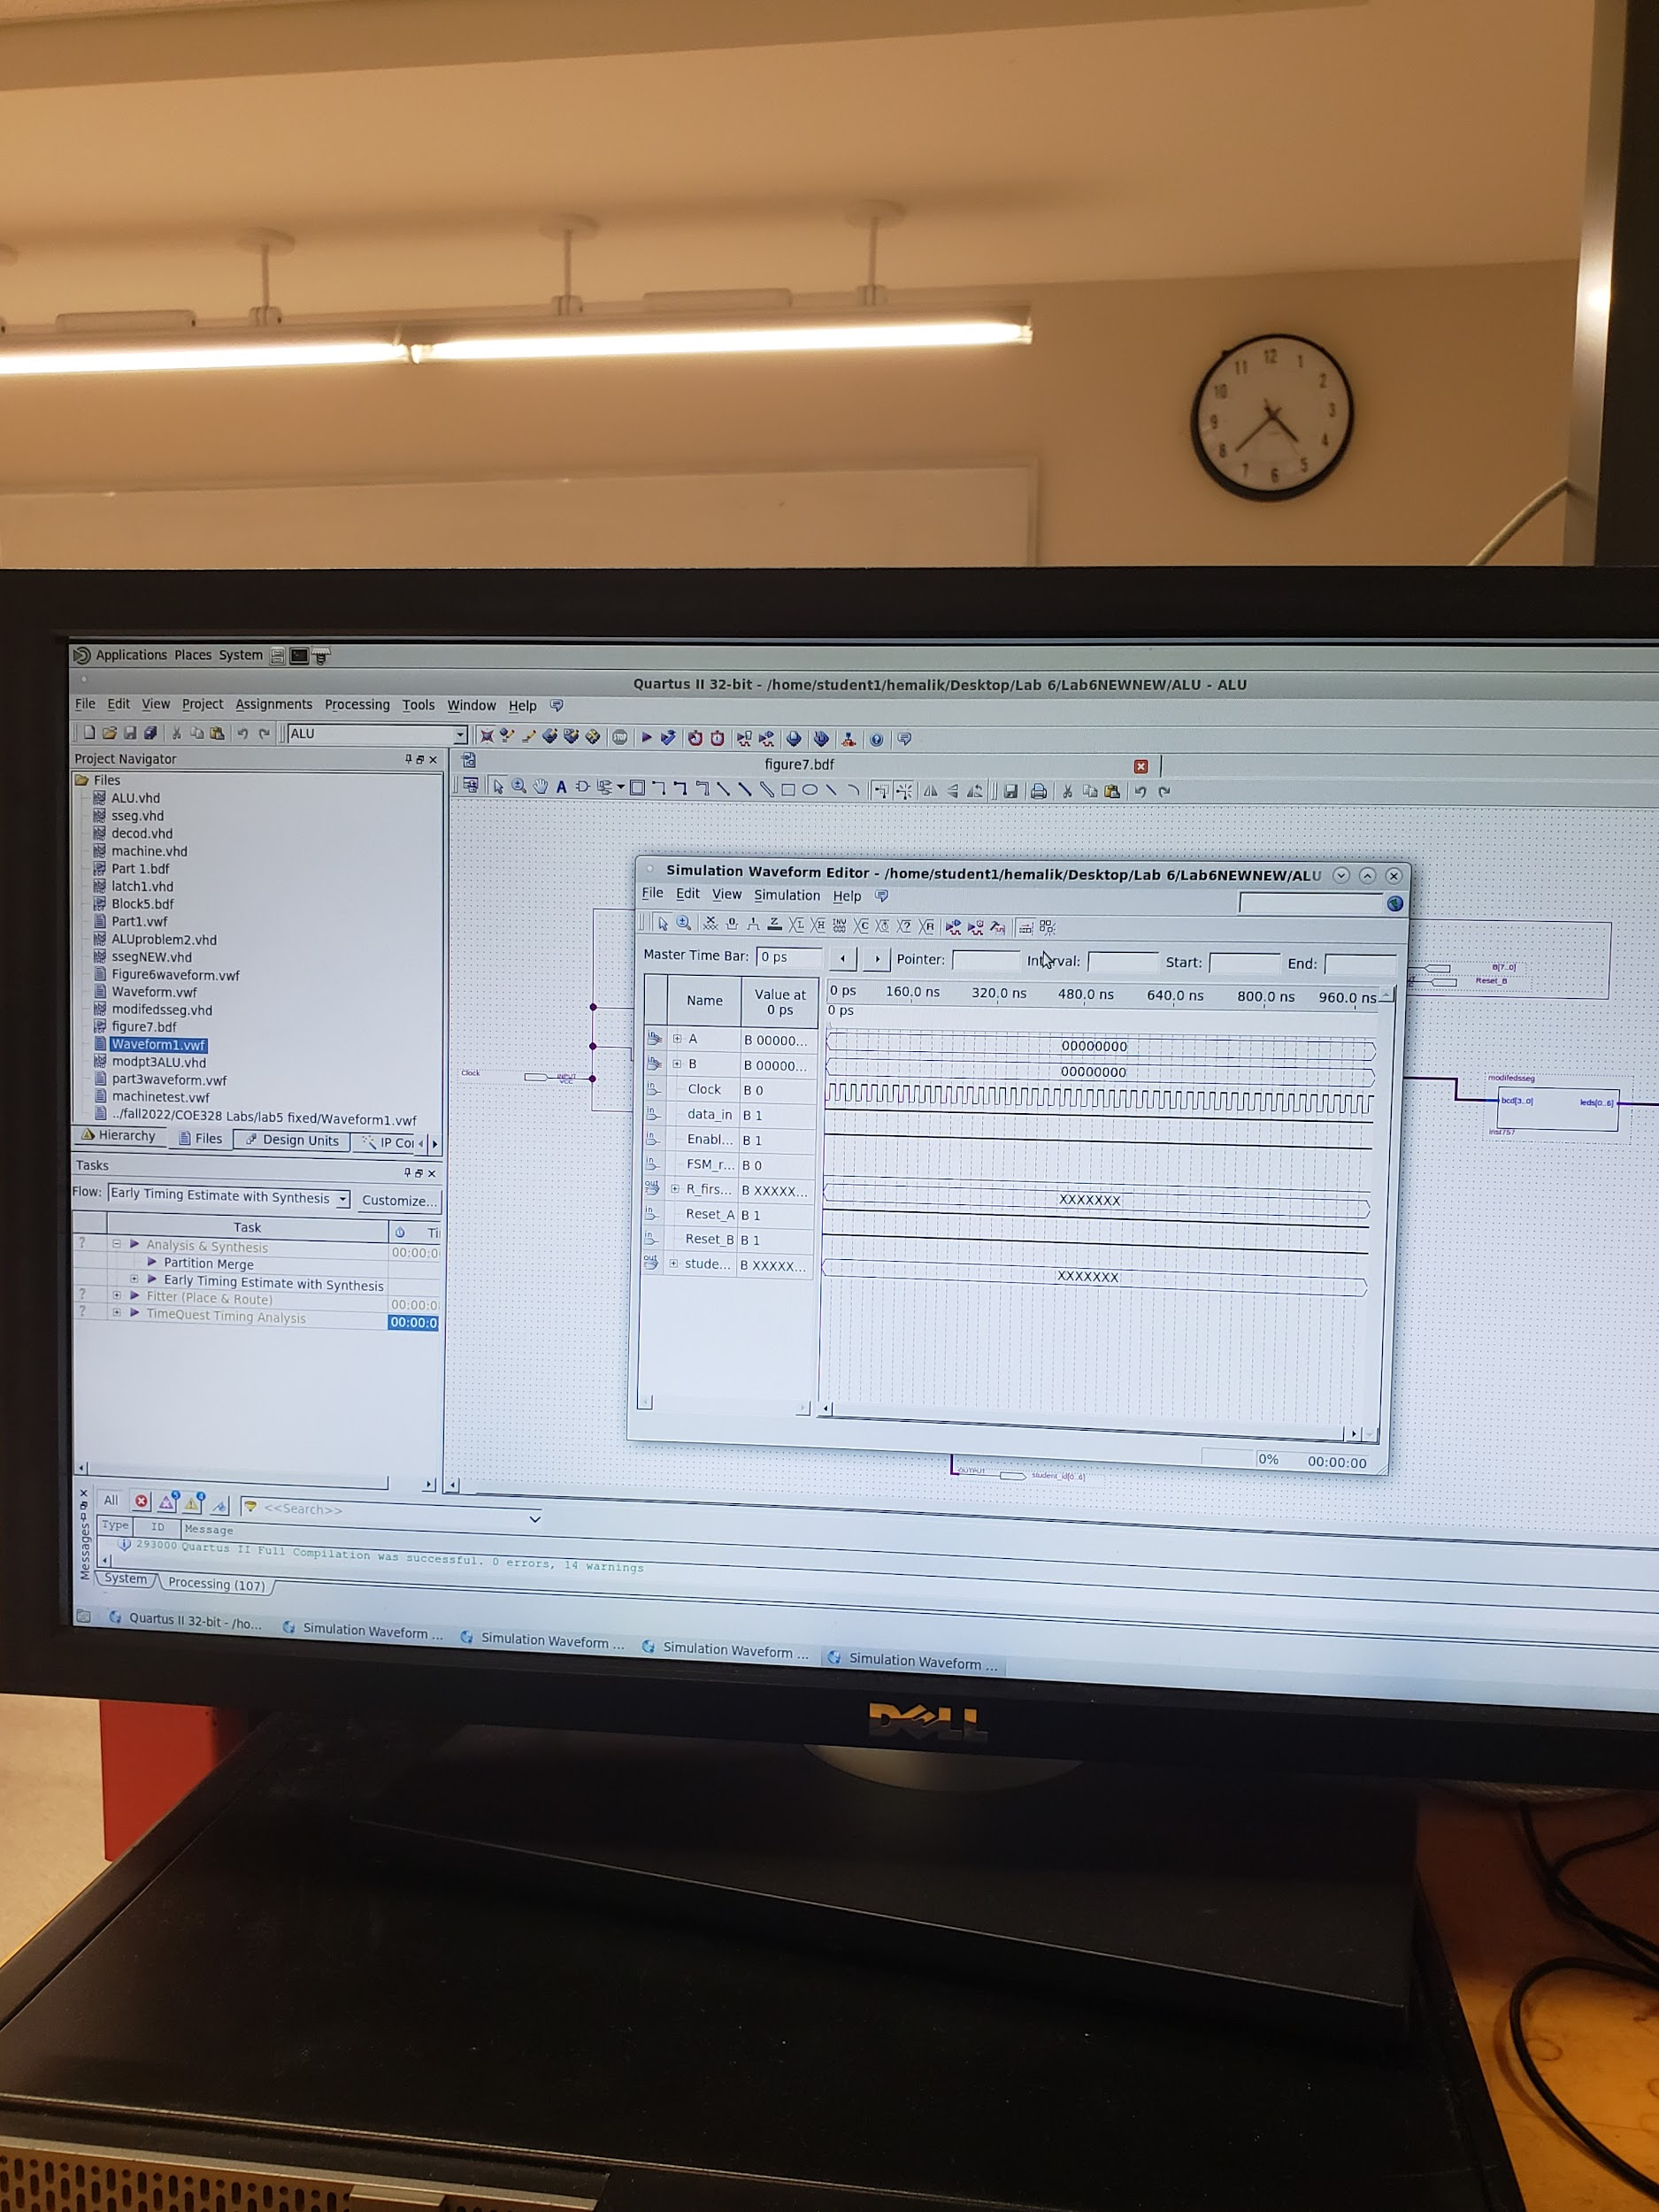

This is Problem 3VHDL code, block diagram schematic, and waveform. There was some issue with the software that's why waveform outputs were getting errors when displaying. Sajjad looked over the overall and said it was correct.

Conclusion:

To conclude, the main objective of this two week laboratory experiment was to design and construct an Arithmetic and Logic Unit (ALU) in VHDL environment and implement it on an FPGA board. This was all done using knowledge and work from our previous labs in the Quartus simulator all implemented together in this final lab.